RESEARCH PAPER

On

COMMUNITY FORUM

**B.TECH 2ND YEAR**

**SEMESTER: 4th**

**SESSION: 2021-2022**



**DEPARTMENT OF COMPUTER SCIENCE & ENGINEERING**

**SHARDA UNIVERSITY, GREATER NOIDA**

**Submitted By:**

**Name of Student:-- Roushan**

**System ID:-- 2020471571**

|  |  |
| --- | --- |
|  | **ABSTRACT** |

A Community Forum is an online “meeting place” that is used to engage with others to debate, share knowledge and communicate with others about a wide range of topics participants are interested in discussing.

The project titled “Community forum” is designed using MERN with Microsoft Visual Studio.Net 2008 as front end as well as back end which works in The coding language used is MERN.

1. This project is aimed at developing online form for the group discussion. This is a web-based tool. Any user can post the doubts topics and can reply for the other user doubts. The user can invite others for Discussion and submit query. This is useful for a small office, school or a department or for that matter any group who is interested to organize it effectively. Facility to share the resource and post articles that can be viewed by registered user.



**INTRODUCTION**

A Community Forum is an online “meeting place” that is used to engage with others to debate, share knowledge and communicate with others about a wide range of topics participants are interested in discussing.

As it relates to customer experience, a Community Forum is a type of self-service support where customers can find a resolution to their problems without having to contact a customer service agent.

**An**[online community forum](https://vanillaforums.com/en/features/forums/)**is an online space created by an organization or a brand, where members, customers and fans alike can congregate, ask questions, receive peer-to-peer support, discuss interests surrounding the brand and make social connections.**

There are essentially two types of community platforms:

1. Branded community platform
2. Social media platform

**FEATURES OF THIS PROJECT……**

1. Login user can access private chat feature .
2. THOSE WHO WILL SIGN IN /UP PRIVATE ACCOUNT MANAGEMENT SECTION.
3. THOSE who will create an account can access the main section and can post queries , give suggestions.

**LITERATURE SURVEY**

 As the increasing interest in using Internet and web communication technology; the online discussion forum has being increasing used by a lot instructors to help support classroom learning. In the Student Interactions in Online Discussion Forum: Empirical Research from ‘Media Richness Theory’ Perspective, it indicates, “The use of online discussion forum has emerged as a common tool and an effective way of engaging students outside the classroom. The online discussion forum is an e-learning platform that allows students to post messages to the discussion threads, interact and receive feedback from other students and instructor, and foster deeper understanding towards the subject under study. In an ODF there is no loss of data as the students’ written messages are stored in the virtual space, and can be retrieved and reviewed anytime. It also provides students the flexibility of time and place to reflect on the previous postings to the discussion thread and thus actively engages them in a meaningful and intellectual experience.”

In the Center for teaching’s Blogs and discussion Board article, it describes the online discussion board is “similar to blogs, a discussion board allows multiple people to respond to comments and questions. They are threaded, in that one in a response to a particular message is nested under the message to which it is a response. Replies that are associated with the same post are grouped together, creating message threads that can be expanded and collapsed. The nesting is usually indicated in the online environment by indentation, much as the organization of major and minor points is indicated in a formal outline by indentation.” According to the study done on the Education Center for Applied Research of undergraduate students, 21% of students would like instructor to increase of online forum and 21% like instructor to increase the usage of online discussion board. And Students prefer, and say they learn more in, classes with online components.

According to the study from the WPI teaching with technology collaborator. “The students are more like to utilize critical thinking skill using discussion boards because it force students to read other perspective and carefully consider a respond. In addition, students participate more regularly and in a more thoughtful manner than they would normally do in face to face instructional setting because many students are very intimidated by speak in face-to-face classroom, those who are simply shy or quiet.”

However, one of the blogs in Discovery through Elearning article point out that “ the Discussion threads can become complicated and go off topic from the original posting. The can also become tedious as one general thought often splits into many thoughts (posts) and then each of these needs to be responded to separately. This is where some participants will begin to feel the threads become more argumentative instead of collaborative.” But it also point out that “Discussion boards/threads are a great resource tool for allowing participants to freely express their thoughts on a common topic at their own pace and leisure. Participants can scroll forwards and backwards through a conversation to see the overall structure. A sense of virtual communities can be established through frequent contributors. Also as Lucy mention they basically replace the face-to-face discussions that occur within the classroom setting.”

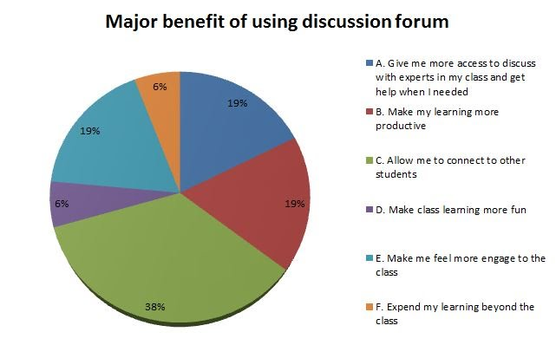

**RESULT:-**

Forum is an online discussion forum where youth or even the experienced professionals discuss their queries related to and get answers for their questions from other talented individuals. An online discussion can be started by asking questions, helping others with answers. The best part is that it is very simple and is free of cost.

**CONCLUSION**S=

[](https://sites.google.com/site/onlinedicussionforum/conclusions/Online-Therapy-Insittute.Online-Coach-Institute-Forums.jpg?attredirects=0)

Although I was expecting majority of the students would have some kind experiencing in using the online discussion forum; I was still surprised to see 100% of students who respond back to my survey all have experience of using the online discussion forum. It shows how the digital technology has deeply integrated into our daily education study.

I think the online discussion forum is great tool to help both teachers and students maintain their communication beyond the classrooms.  It’s also a great way for students to feel more engaged in participating the group discussion; allow them to provide and share their opinions with others at any time and location.

Although some critics feel that using the online discussion forum might have the negative impact on student’s communicate skills and even increase the potential of getting the online bullies. I think there’s always pro and cons on any of the technology inventions and it really depend on how people utilize it.   I personally think the online discussion forum is great technology that helps bring the students and teacher more closer and it's a great way to share and transfer knowledge to each other.

**REFERENCES:-**

1.<https://www.youtube.com/watch?v=j942wKiXFu8&list=PL4cUxeGkcC9gZD-Tvwfod2gaISzfRiP9d> (NET NINJA REACT)

2. Stack overflow , w3schools.

3. geeksforgeeks , react documentation , udemy